**Practice Project 2: Data Types and their Operations**

This practice project will help you to master how to create various data types in Python and carry out appropriate operations on the different data types.

1. The formula used for converting temperature from degree Celsius(C) to degree Fahrenheit (F) is as follows:

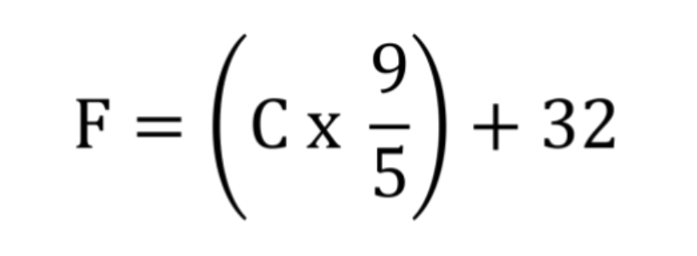

If the temperature is 40 degrees Celsius, what is the corresponding temperature in Fahrenheit? Use Python to solve this problem, and make sure you are also using variables instead of hard coding the temperatures in degrees Celsius and Fahrenheit. Print the final variable storing the temperature in Fahrenheit. Use the temperature variables and print your answer so that your answer reads “100 degrees Celsius is 212 degrees”. No hard coding😊of values into the print statement, instead use the variables referencing the values.

Paste the screenshot of your code and output here.

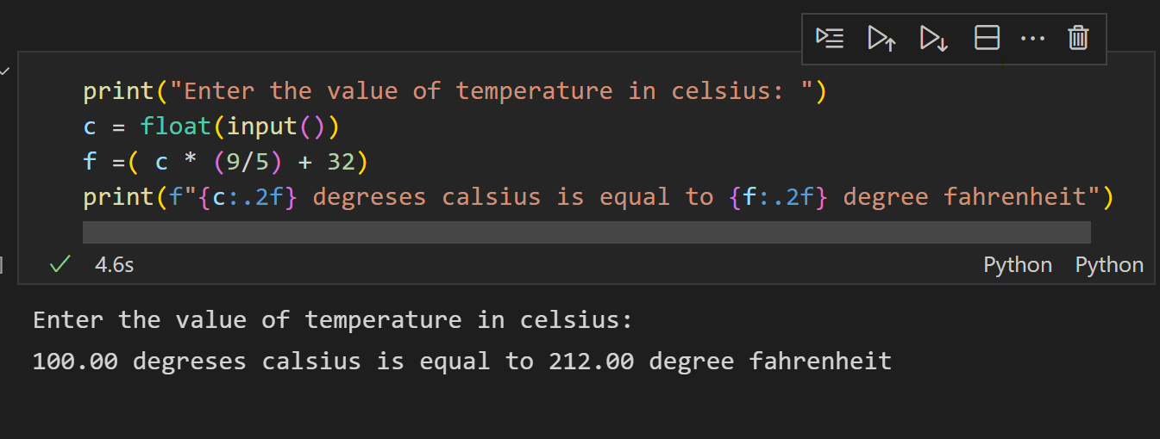

1. The following steps give the name and birth year of a famous inventor
2. Create a variable **first_name** and assign it the value “Thomas”
3. Create a variable **last_name** and assign it the value “Edison”
4. Create a variable **birth_year** and assign it the value, 1847
5. Use f“” string formatting and the three variables created in (a), (b), and (c) to print the statement “Thomas Edison was born in 1847”. Do not hard code the values into the string. Instead, use the variables to plug in those values. Note that, from part (d) to (f), the part “was born in” can be hard coded since we did not assign that part to any variable.

Paste the screenshot of your code and output here.

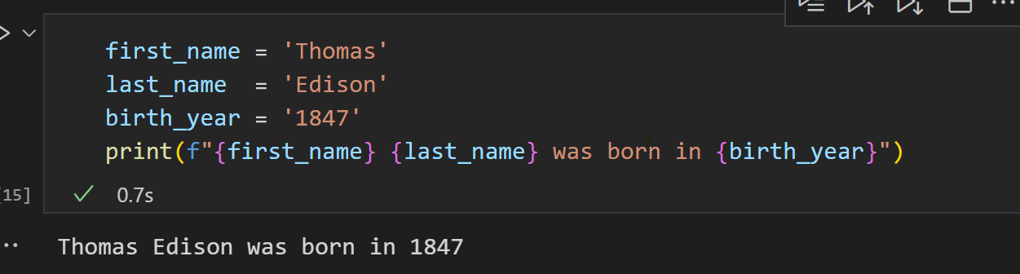

1. Use the .format() method of the string object and the three variables created in (a), (b), and (c) to print the statement “Thomas Edison was born in 1847”. Do not hard code the values into the string. Instead, use the variables to plug in those values.

Paste the screenshot of your code and output here

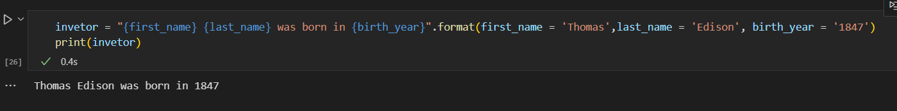

1. Use the plus sign (+), three variables created in (a), (b), and (c) to do a string concatenation inside a print function so that the output of your print statement is “Thomas Edison was born in 1847”. Do not hard code the values into the string. Instead, use the variables to plug in those values.

Paste the screenshot of your code and output here

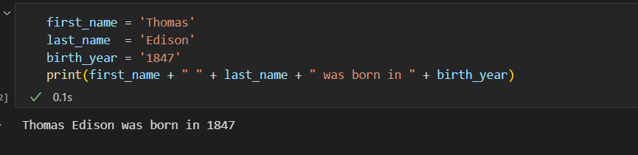

1. a) Write a program that asks a user to provide a sentence. Then count the number of words in the sentence. (Hint: you can use the. split() method to create a list of words, then find the length of the list with the len() function). Figure out how to create your own variables and use the input() function to solve this problem.

Print the sentence and the number of words in the sentence

Paste the screenshot of your code and output here

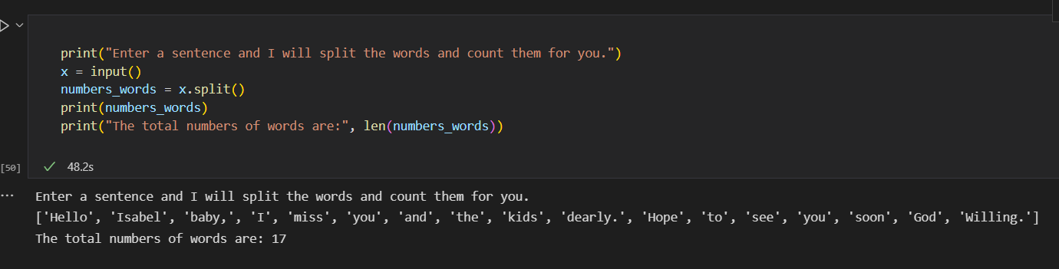

1. a) Write a program to ask a user to provide a sentence. Then count the number of words in the sentence. (Hint: you can use .split() method of the string to create a list of words, then find the length of the list with the len() function).

Paste the screenshot of your code here {Result display above}

1. Here is a list containing the names of all 50 states in the United States.

states = ["Alabama", "Alaska", "Arizona", "Arkansas", "California", "Colorado",

"Connecticut", "Delaware", "Florida", "Georgia", "Hawaii", "Idaho", "Illinois",

"Indiana","Iowa","Kansas","Kentucky","Louisiana","Maine","Maryland",

"Massachusetts","Michigan","Minnesota","Mississippi","Missouri","Montana",

"Nebraska", "Nevada", "New Hampshire", "New Jersey", "New Mexico", "New York",

"North Carolina", "North Dakota", "Ohio", "Oklahoma", "Oregon", "Pennsylvania",

"Rhode Island", "South Carolina", "South Dakota", "Tennessee", "Texas", "Utah",

"Vermont", "Virginia", "Washington", "West Virginia", "Wisconsin", "Wyoming"]

1. Create this list in Python, assign it a list variable called states, and print the list in the variable.

Paste the screenshot of your code and output here

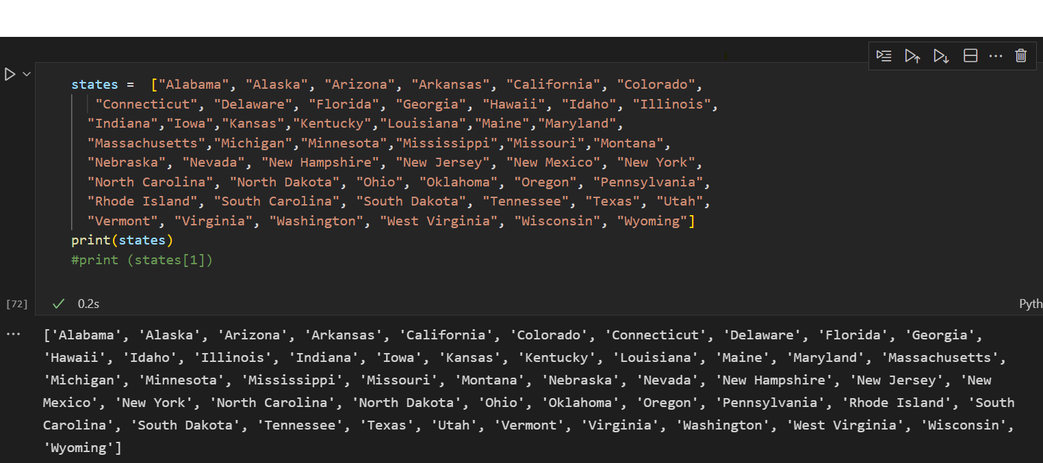

1. Print the first state. Use indexing. (Remember that Python starts counting from 0, so the 4th state for example will correspond to an index of 3)

Paste the screenshot of your code here

Print (states[0]) alabama

1. Print the first and the last state in a single print statement. Use indexing.

Paste the screenshot of your code here

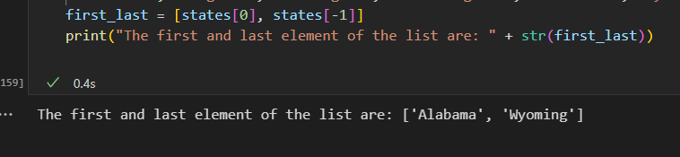

1. Use a python code to output the index or position of “Mississippi”

Paste the screenshot of your code and output here

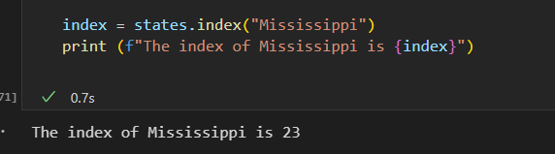

1. Use indexing to extract the state “Alabama”, change the extracted state to uppercase using the .upper() method of the string, then replace “Alabama” in the list, with the uppercase “ALABAMA” using indexing and an
2. assignment statement. Finally, use the keyword “is in” to check whether “ALABAMA” is in the list. For example, “ALABAMA” is in states. Note: You
3. should create a variable referencing the uppercase “ALABAMA”. It is always a good thing to assign values to variables if the value needs to be reused later. Paste the screenshot of your code and output here

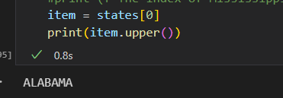

1. Append “Puerto Rico” to the list of states, then print the last state in the list again. You should use negative indexing to extract the last state to print it.

Paste the screenshot of your code and output here

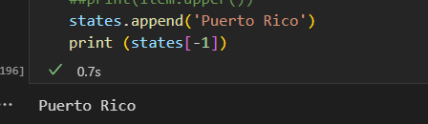

1. Use the slicing operator to extract from the 2nd to the 10th state in the list (use positive indexes and remember that Python starts counting from 0, so the 4th state for example would correspond to an index of 3).

Paste the screenshot of your code here

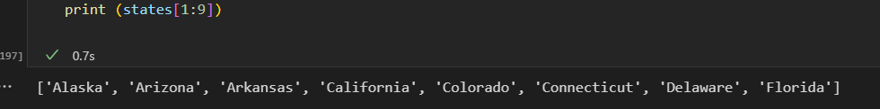

1. Use negative indexes to extract from the 40th up to including the last state in the list

Paste the screenshot of your code here

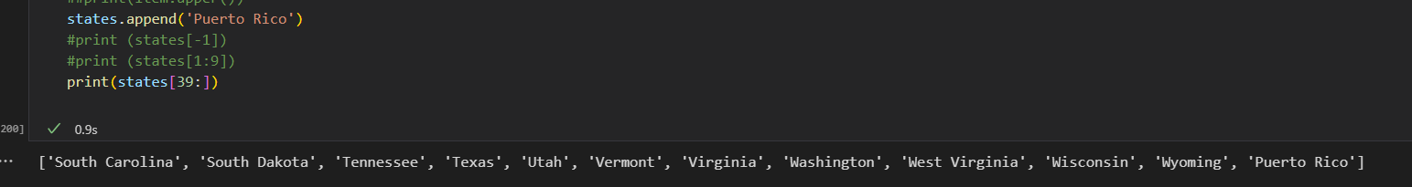

1. Use list concatenation to add “Guam” to the list of states (you need to use the plus sign). Then print the index of “Guam”.

Paste the screenshot of your code here

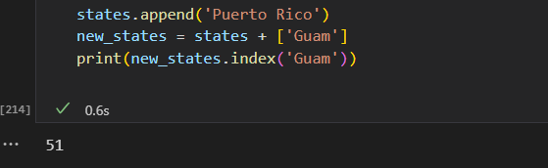

1. Print the length of the list of states now.

Paste the screenshot of your code here

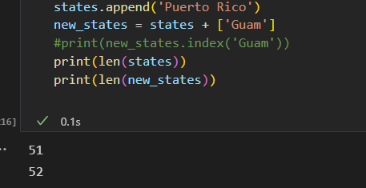

1. Pop the first state, then print the length of the states in the list again.

Paste the screenshot of your code here

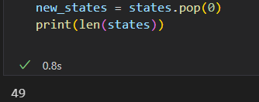

1. Sort the states in the reversed order

Paste the screenshot of your code and output here

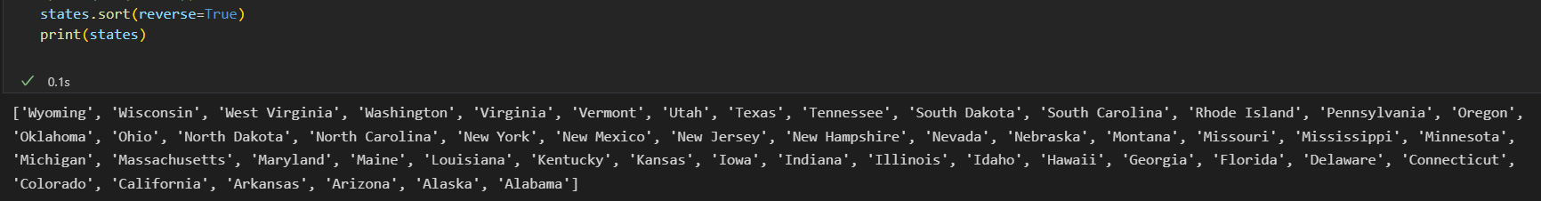

1. You will need to create an empty dictionary, then populate it with the names of three individuals and states where they live. You will choose your own names and states.
2. Create an empty dictionary

Paste the screenshot of your code and output here

1. Populate the dictionary with a list of three names and a corresponding list of three cities where these individuals live. So, your dictionary should have two keys (**name** and **city**)

Paste the screenshot of your code and output here

1. Print the dictionary

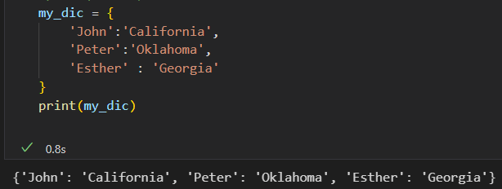

1. Print the second name in the dictionary, then print the second city in the dictionary.

Paste the screenshot of your code and output here

7) Let’s assume you have two folders on your desktop that contain files as follows. The file names are in put two sets.

folder_A = {“file1”, “file2”, “file4”, “file7”, “file8”, “file9”, “file10”}

folder_B = {“file1”, “file2”, “file12”, “file7”, “file13”, “file3”, “file11”}

create these two set variables in Python, then use Python to:

1. Find the files that are in folder A and are also in folder B
2. Find the files that are in folder A only, and not in folder B
3. Find the files that are in folder B only, and not in folder A
4. Find the files that are in folder B only, and not in folder A?
5. Find the files that are either in folder A or are in folder B (that is all the files the two folders)

Paste the screenshot of your code and output here

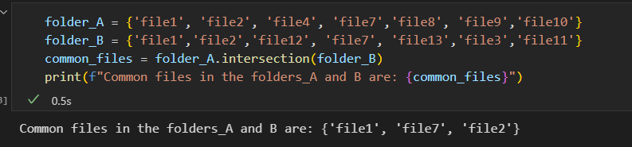

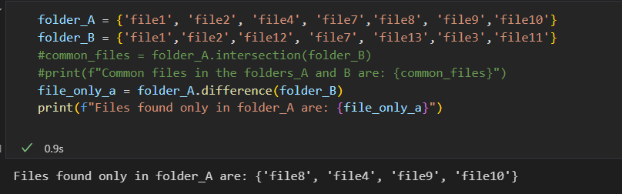

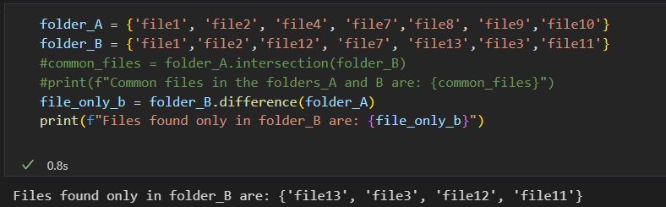

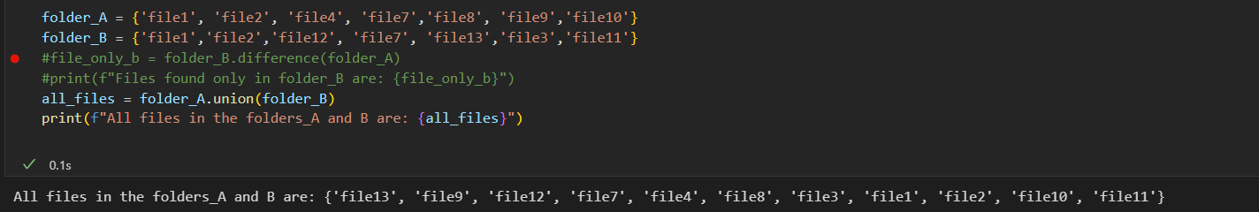

8) Collect three numbers from a user using the input() function and find the average of the three numbers:

a) Initialize or create an empty list and assign it to a list variable called **numbers.**

b) Collect the first number into a variable **num1,** append the number to the list variable, **numbers**.

c) Collect the second number into a variable **num2** andappend the number to the list variable **numbers**.

d) Collect the third number into a variable **num3** andappend the number to the list variable **numbers**.

e) Then calculate the average of the numbers in the **numbers** list using the sum() and len() functions.

Use a variable **average** to store your average value.

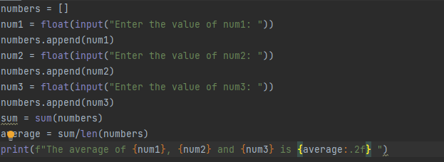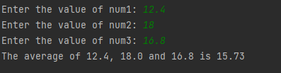

9) Let’s assume that the rhyme below is your favorite rhyme

"Jack and Jill went up the hill  
To fetch a pail of water.  
Jack fell down and broke his crown,  
And Jill came tumbling after.  
Then up got Jack and said to Jill,  
As in his arms he took her,  
'Brush off that dirt for you’re not hurt,  
Let’s fetch that pail of water. '  
So Jack and Jill went up the hill  
To fetch the pail of water,  
And took it home to Mother dear,  
Who thanked her son and daughter"

Copy this rhyme or text into Python and assign it to a string variable called **favorite_rhyme.**

1. Then use Python to count how many of the words “Jack” are in the rhyme.
2. Use the split() method of the string object to split the text into a list and assign the results to a list variable called **rhyme_words.**

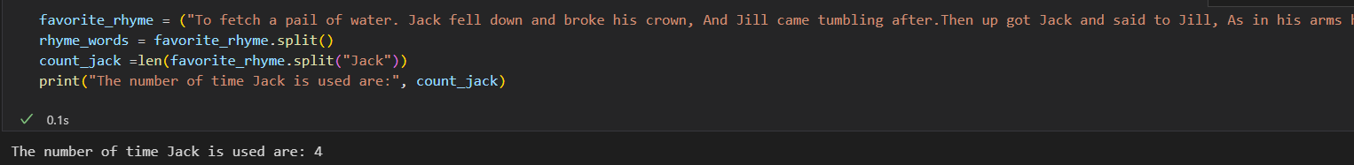

1. Then use the .join() method of the list to join the words in **rhyme_words** into the original text consisting of sentences.

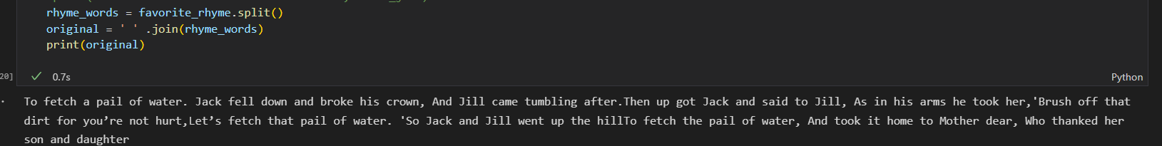

1. Extend the sentence using an augmented statement such as

favorite_rhyme += "This is the end of my rhyme!"

print(favorite_rhyme)

Did the output have the last sentence added? Yes

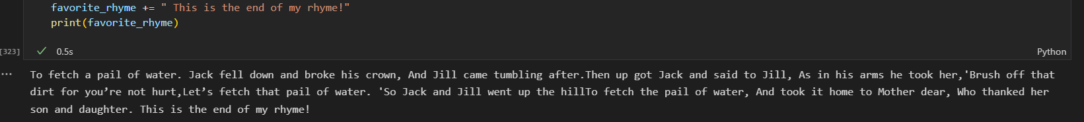

The idea here is that sequences such as strings, tuples, and lists can be extended using augmented statements.

10) You will write two programs

a) Write a program that displays the first and the last word of a sentence input by a user

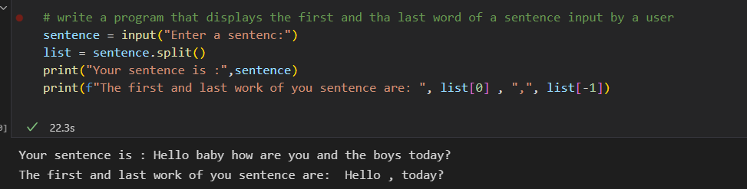

b) Write a program that requests a three-part name, for example, *Jackson Rob Johnson*. The program should then display the middle name such as *Rob*.

